“Utilization of Marble dust as filler material in Asphalt Concrete”
Author
Mr. Fahad Jan
Email: engrfahad77@yahoo.com
Cell: +92 3436822673
Lecturer, Department of Civil Engg, University of Engineering & Technology Peshawar, Pakistan
Co-Authors

Mr. Atif Ali
Email: engr_atif143@yahoo.com
Cell: +92 3439212993

Mr. Sajjad Ali
Email: engr.sajjad@yahoo.com
Cell: +92 3409553039

Mr. Touseef Ahmad
Email: engr.touseef92@gmail.com
Cell: +92 3154321055
Students of B.Sc., Department of Civil Engg, University of Engineering & Technology Peshawar, Pakistan

Abstract
The purpose of this study is to evaluate the use of marble dust as filler in asphalt concrete. Marble dust is produced as waste during the shaping and dressing of marble. Hence to ensure optimal usability, marble dust has been used to replace filler and Mix design for bituminous concrete with marble dust was adopted. Different tests including Marshall Stability, flow, VFA and VMA were carried out to evaluate the effect of different percentages of this Industrial waste on the properties of asphalt filler matrix. These properties were compared with the properties of the mix having stone dust as filler. It was found that the stability for modified asphalt concrete is 1.63% greater than the conventional one. Similarly the optimum binder content was decreased by 4.05% which proved that marble dust filler act as a bitumen extender and also decreases the overall cost of highway construction. It was concluded through laboratory investigation that marble dust can be successfully utilized in bitumen as filler up to 7% and this will give us a stable, economical and environment friendly pavement thus reducing the overall pollution which may otherwise caused by the marble waste in water streams and rivers.
Keywords: Marble dust, filler, Asphalt concrete, conventional and optimum binder content.
Introduction
The use of marble for construction involves elaborate processing, such as cutting, grinding and polishing. A large amount of waste is generated during these processes as more production of marble results in more waste. Marble slurry is generated as a by-product during processing of marble blocks. The waste is approximately 20 % of the total marble handled. The marble cutting industries are dumping this marble slurry in nearby lands causing occupation of a large area of land. When this slurry dries up causing serious environmental pollution, threatening both agriculture and public health reducing the porosity and permeability of the top layers of soil causing water logging. Furthermore, the fertility of the soil is reduced with the increase in alkalinity. It is a source of ground water contaminate, produce drainage problems and acts as a bourdon on the landfills.
The main purpose of this research study is to test the suitability of the use of marble dust as filler in asphalt concrete as the properties of marble dust are similar up to some extent to the stone dust. As the construction of highway requires a huge outlay of investment, therefore if marble waste is utilized in asphalt concrete, this may l give us a stable and economical pavement as well as would reduce the problem of environmental pollution.
Literature Survey
Many studies has been carried on the utilization of various kinds of waste disposals such as fly ash, reinforced fly ash, polypropylene fiber, demolition waste result in the change of mechanical properties of soil and change in optimum moisture content and other properties (A. Arul rajah.et.al 2013).Similarly investigations have been carried out using the modified mix for evaluation of the marshal properties, indirect tensile strength test and fatigue behavior of different mixes. Howeverr,study on bituminous concrete mix with marble dust as a filler is limited and further detailed investigation is required to obtain more reliable results.
In 1993,Gupta conducted marshal stability tests on mixes with 80/100 grade bitumen and fillers like cement, fly ash, and stone dust. The maximum and minimum values were observed for stone dust fillers and fly ash fillers respectively. In 1996,Ishai and Craus summarized a long term research effort conducted in Israel on aggregate and filler properties that significantly influenced the behavior and durability of bituminous paving mixtures. Meanwhile, six types of fillers were used to evaluate them physically and chemically, the rheological characterization of filler-asphalt mastics, and the strength and durability tests on sand-asphalt mixtures and bituminous mixtures.
[Baig and Wahhab 1998] investigated the effectiveness of using hedmanite (Rockwool natural fibers) as filler in improving the performance of asphalt concrete pavements. Results indicated that better quality asphalt concrete mixes can be prepared using lime rather than hedmanite as filler.

Research Methodology
The details of main components , their respective tests and results are provided .It includes
Coarse aggregates:Provides compressive and shear strength and shows good interlocking properties. Material retained on AASHTO No. 4 sieve (4.75mm). (From Margalla source)
Fine aggregates:Fills the voids in the coarse aggregate and give stiffness to the binder. Material passing AASHTO No. 4 sieve (4.75mm). (From Margalla source)
Filler:Fills the voids between the fine aggregate provides stiffness and offers permeability. Material passing AASHTO NO. 200 sieve. Ordinary Portland cement, conventionally stone dust and here marble dust is used as filler (Source: Mohmand agency)
Binder:Fills the voids and also hold the aggregate by adhesive forces. Grade 60/70 bitumen is used (Source:Attock Oil refinery).
Tests on Aggregate:
Aggregate used are to be sufficiently strong, hard, tough and durable and of desirable right shape to withstand the traffic effects. For that purpose various quality tests were conducted on aggregate as given below.
Table 1: Results of Quality tests on aggregate
Results of Quality tests on aggregate
S No. | Description | Results | AASHTO Spec’s Limits
1 | Loss Angles Abrasion test | 23.7% | Max. = 40 %
2 | Impact value test | 9.30% | < 10% = very strong
3 | Soundness test | 2.38% | Max. = 12 %
4 | Shape test | 9.22% | < 15 %
5 | Aggregate water absorption test | 1.4% | < 3 %
6 | Stripping value test | 97.4% | Min. 95 %

Test protocol for Bitumen:
Properties of bitumen used are to be tested for Flash point, Fire point, Softening point and Penetration value and results are given below
Table 2: Results of Quality test on bitumen
Results of Quality tests on bitumen
S NO. | Description | Results | AASHTO Spec’s Limits
1 | Flash point test | 221 ºC | > 200
2 | Fire point test | 299 ºC | > 220
3 | Softening point test | 51 ºC | 44 --- 55 ºC
4 | Penetration test | 66 mm | 60/70 Grade

Preparation of Hot Mix Asphalt (HMA)
Different steps in finalizing HMA are given below.
- Selecting the aggregate grading to be used
- Determining the proportion of each aggregate size required to produce the design grading.
- Determining the specific gravity of the aggregate combination
- Preparing the trial specimens with varying asphalt contents
- Determining the specific gravity of each compacted specimen
- Performing stability tests on the specimens
- Calculating the percentage of voids and percent voids filled with bitumen in each specimen
- Selecting the optimum binder content from the data obtained
- Evaluating the design with the design requirements.
Procedure:
- In the Marshall Test method of mix design six compacted samples were prepared for each binder content.
- At least four binder contents were tested to get the optimum binder content.
- All compacted specimens were subjected to the following tests
- Bulk density determination
- Stability and Flow determination
- Density and voids analysis

Analysis and Results
Analysis and results are better explained in the form of following graphs and tables
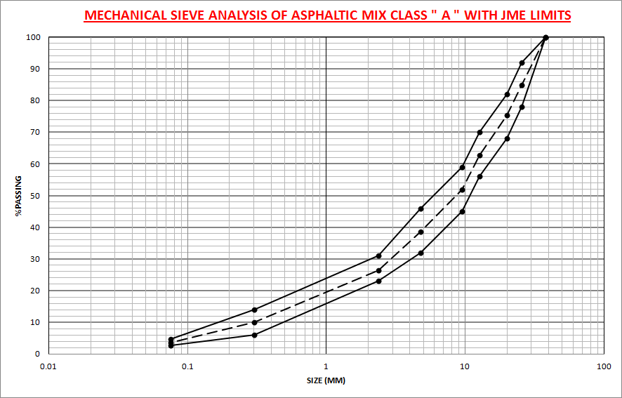Graph 1: Gradation curve of aggregate
Table 3: Blending of Aggregate
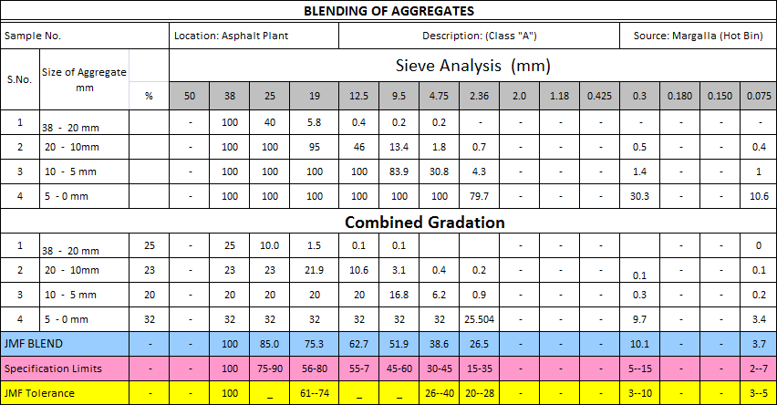

Table 4: Calculation of various properties of the asphalt mix modified with marble dust filler
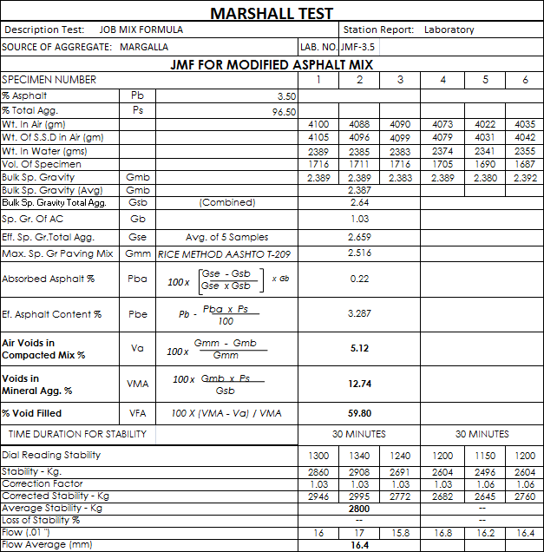

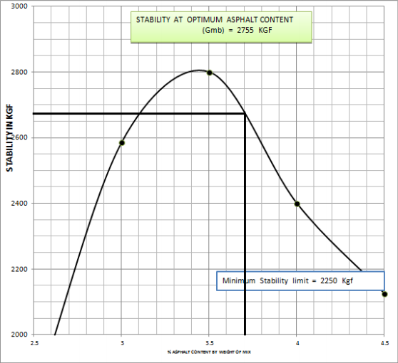
Graph 2: Stability at Optimum asphalt content for conventional AC mix
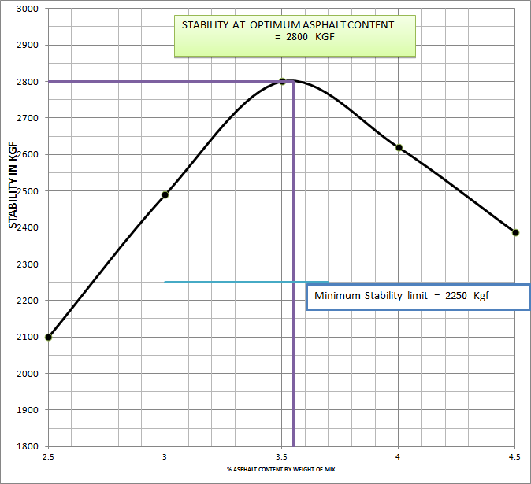
Graph 3: Stability at Optimum asphalt content for modified AC mix

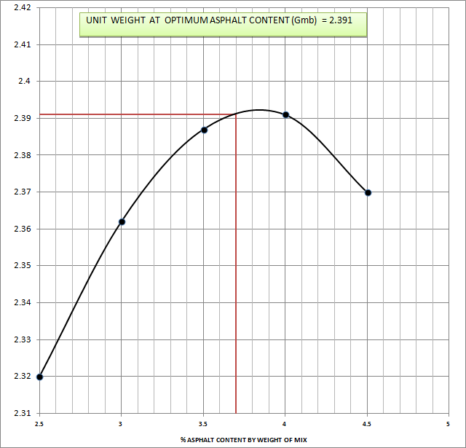
Graph 4: Unit weight at Optimum asphalt content for conventional AC mix
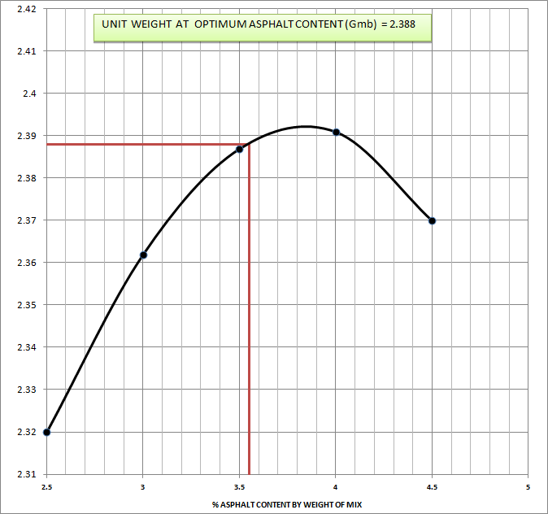
Graph 5: Unit weight at optimum asphalt content for modified AC mix

Other properties of the mix like VMA, VFA, Flow and air voids were also determined.The details are provided in the following table
Table 5: Comparative results of various properties of conventional and modified asphalt mix
S. No. | Description | Conventional Test Result | Modified Test Result | AASHTO Specified Limits
1. | Stability at optimum asphalt content | 2755 Kg | 2800 Kg | 2250 kg
2. | Unit weight at optimum asphalt content | 2.391 | 2.388 | ---
3. | Percent air voids at optimum asphalt content | 4.59 % | 5.09 % | 4 % --- 6 %
4. | VMA at optimum asphalt content | 12.48 % | 13.7 % | 12 % min
5. | Flow at optimum asphalt content | 18 mm | 17.2 mm | 12 --- 21mm
6. | Optimum asphalt content | 3.7 % | 3.55 % | 3 % min
7 | VFA at optimum asphalt content | 64.1% | 62.89 % | ----

Conclusion and Recommendations
Conclusion:
The comparative study of the asphalt mix design with conventional stone dust filler and marble dust fillers conclude that;
- The Marshall properties of the mix indicates that the addition of marble dust to the asphalt concrete improved properties than asphalt concrete mix with stone dust as filler
- The optimum binder content was reduced because the marble dust act as a bitumen extender hence make the mix economical
- Hence the use of marble dust as filler in asphalt concrete mix is encouraging and it can be successfully utilized in bitumen, will give us a more economical and environment friendly pavement.

Recommendations:
- This research work may be further extended to perform field test on test tracks.
- The asphalt concrete with modified filler may also be tested for rutting potential by using wheel tracker device.
- Since the marble dust used in this research work was obtained from Mohmand Agency of KPK province, Pakistan, the asphalt concrete may also be tested while using marble dust of the regions like Buner, Swat, Margalla and Nowshera districts of Pakistan where marble industry is developed. A comparative study may also be continued for same.
- Further studies are recommended to evaluate the behavior of the bituminous concrete mixes with marble dust filler tlike rutting and fatigue of pavement.
References
[1] Gupta, P.K. (1993). “A laboratory investigation on role of filler materials on the performance of bituminous mixes”. M.E. Thesis, University of Roorkee, Roorkee, India.
[2] Ali, N., Chan, J.S., Simms, S., Bushman, R. and Bergan, A.T. (1996). “Mechanistic evaluation of fly ash asphalt concrete mixtures”. Journal of Materials in Civil Engineering, ASCE, 8(1), 19-25.
[3] Baig, M.G., and Wahhab, H.I.A., (1998). “Mechanistic evaluation of hedmanite and lime modified asphalt concrete mixtures”. Journal of Materials in Civil Engineering, ASCE, 10(3), 153-60.
[4] William H. Langer, Lawrence J. Drew, Janet S. Sachs. Aggregates and environment, AGIEnvironmental Geoscience AdvisoryCommittee 2004.
[5] Johnny Bolden, Taher Abu-Lebdeh and Ellie Fini, Utilization of recycled and waste materials in various construction applications, American Journal of Environmental Science, 9 (1): 14-24, 2013

